Single LinkedList

A singly linked list is a type of linked list that is unidirectional, that is, it can be traversed in only one direction from head to the last node (tail).
Each element in the LinkedList is called the Node. Each Node of the LinkedList contains two items: 1) Content of the element (data)2) Pointer/Address/Reference(next) to the Next Node in the LinkedList.

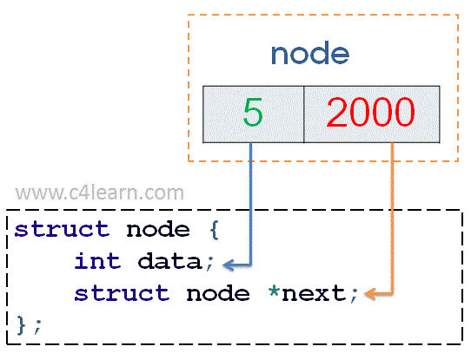
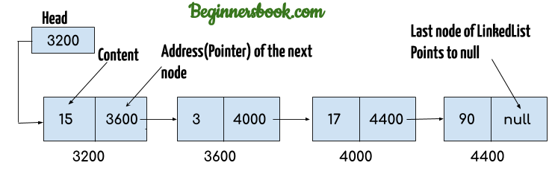
// implementation of a Node in a linked List
//generic type-
public class ListNode<T> {
private T data;
private ListNode<T> next;
}

// intgerType-
public class ListNode1 {
private int data;
private ListNode1 next;
}
public class SingleLinkedList1 {

public void display(ListNode head) {
if (head == null) {
return;
}

ListNode current = head; //10
while (current != null) {
System.out.print(current.data + "====>");
current = current.next;
}
System.out.println(current);//null
}

private static class ListNode {
private int data;
private ListNode next;

public ListNode(int data) {
this.data = data;
this.next = next;
}
}

public static void main(String[] args) {
ListNode head = new ListNode(10);
ListNode second = new ListNode(8);
ListNode third = new ListNode(1);
ListNode fourth = new ListNode(11);
//attach them togeter to form a list
head.next = second;// 10->8
second.next = third;// 10-> 8->1
third.next = fourth;// 10-> 8-> 1-> 11 ->null
SingleLinkedList1 s1=new SingleLinkedList1();
s1.display(head); }}

output:10====>8====>1====>11====>null

Doubly Linked List
Single linked list each node is divided into two part.
Double Linked List each node divided into three part.

A Doubly Linked List (DLL) contains an extra pointer, typically called previous pointer

Doubly linked list is a complex type of linked list in which a node contains a pointer to the previous as well as the next node in the sequence. Therefore, in a doubly linked list, a node consists of three parts: node data, pointer to the next node in sequence (next pointer) , pointer to the previous node (previous pointer).
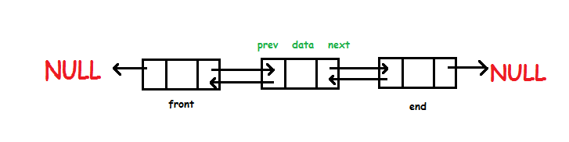
tail
head
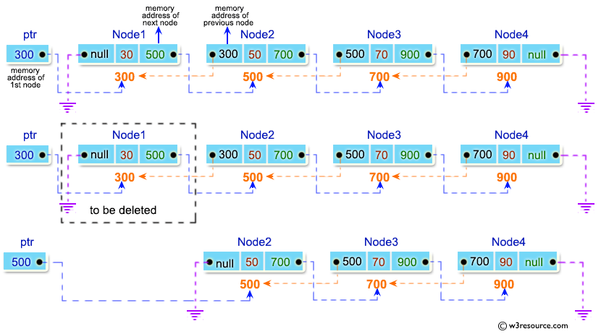

package com.ojas.doubleLinkedList;

public class DoubleLinkedList {
private ListNode head;
private ListNode tail;
private int length;

private class ListNode {
private int data;
private ListNode previous;
private ListNode next;

public ListNode(int data) {
this.data = data;
}
}

public DoubleLinkedList() {
this.head = null;
this.tail = null;
this.length = 0;
}

// checking doublie linked list empaty or not
public boolean isEmpty() {
return length == 0; // head == null
}

public int length() {
return length;
}

// adding a variable into list
public void insertLast(int value) {
ListNode newNode = new ListNode(value);
if (isEmpty()) {
head = newNode;
} else {
tail.next = newNode;
}
newNode.previous = tail;
tail = newNode;
length++;
}

// display doubleLinkedList fordDirection
public void displayForward() {
if (head == null) {
return;
}
ListNode temp = head;
while (temp != null) {
System.out.print(temp.data + "--> ");
temp = temp.next;
}
System.out.print("null");
System.out.println();
}

// display list into backward direction
public void displayBackward() {
if (tail == null) {
return;
}
ListNode temp = tail;
while (temp != null) {
System.out.print(temp.data + " --> ");
temp = temp.previous;
}
System.out.print("null");
}

public static void main(String[] args) {
DoubleLinkedList dll = new DoubleLinkedList();
dll.insertLast(1);
dll.insertLast(10);
dll.insertLast(15);
dll.insertLast(25);
dll.displayForward();
dll.displayBackward();
}
}

OUTPUT:
1--> 10--> 15--> 25--> null
25 --> 15 --> 10 --> 1 --> null

Circular Singly Linked List
In a singly linked list, for accessing any node of linked list, we start traversing from the first node. If we are at any node in the middle of the list, then it is not possible to access nodes that precede the given node. This problem can be solved by slightly altering the structure of singly linked list. In a singly linked list, next part (pointer to next node) is NULL, if we utilize this link to point to the first node then we can reach preceding nodes. Refer this for more advantages of circular linked lists.
The structure thus formed is circular singly linked list look like this:
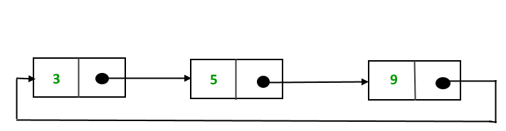

Doubly Circular Linked List
Circular Doubly Linked List has properties of both doubly linked list and circular linked list in which two consecutive elements are linked or connected by previous and next pointer and the last node points to first node by next pointer and also the first node points to last node by previous pointer.
